# **Code Output**

## **Initial Screen: Adding a new product.**

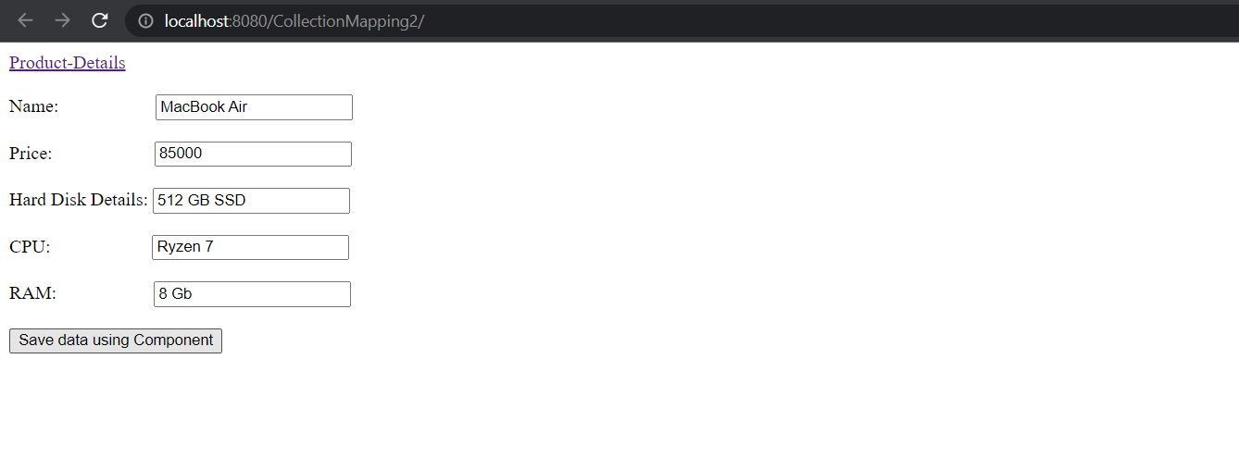

## **After successful entry it takes us to Product List page:**

